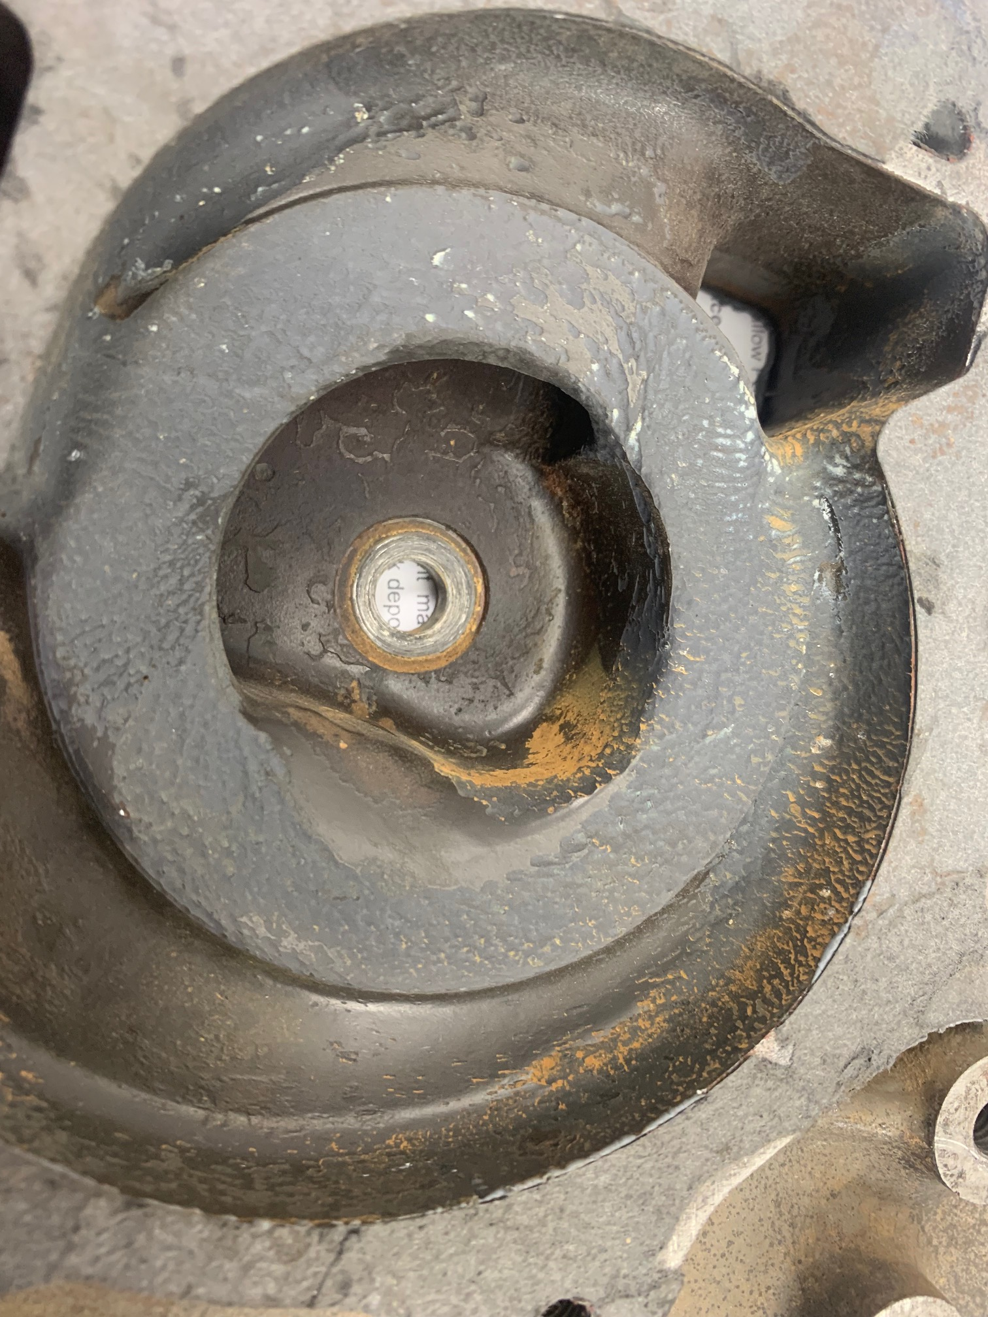

You can see the ripples in the once smooth timing cover, caused by cavitation. These continue to create cavitation.

Still need some help with this task?
www.patrolapart.com.au/tutorials

You can also contact us via phone if you need but we generally find the video along with this install guide is all you will need!

All of our contact details are listed on the next page.



Contact Us

PATROLAPART/NAVARAPART
39 Industrial Park Drive
Lilydale, VIC 3140

Phone: (03) 9735 9099
Email: sales@patrolapart.com.au
LMCT: 10647

Hi-Flow TD42 Water Pump

Installation Guide

  - In this guide we will show you how to check your impellor-to-timing case clearance while fitting a Hi-Flow water pump. The wrong clearance can cause cavitation which has a large impact on the efficiency of your TD42 cooling system.

You will need
Just some simple tools for this task!
- Small amount of Blu tack
- 12mm socket
- 14mm socket
- Ratchet or Impact Gun

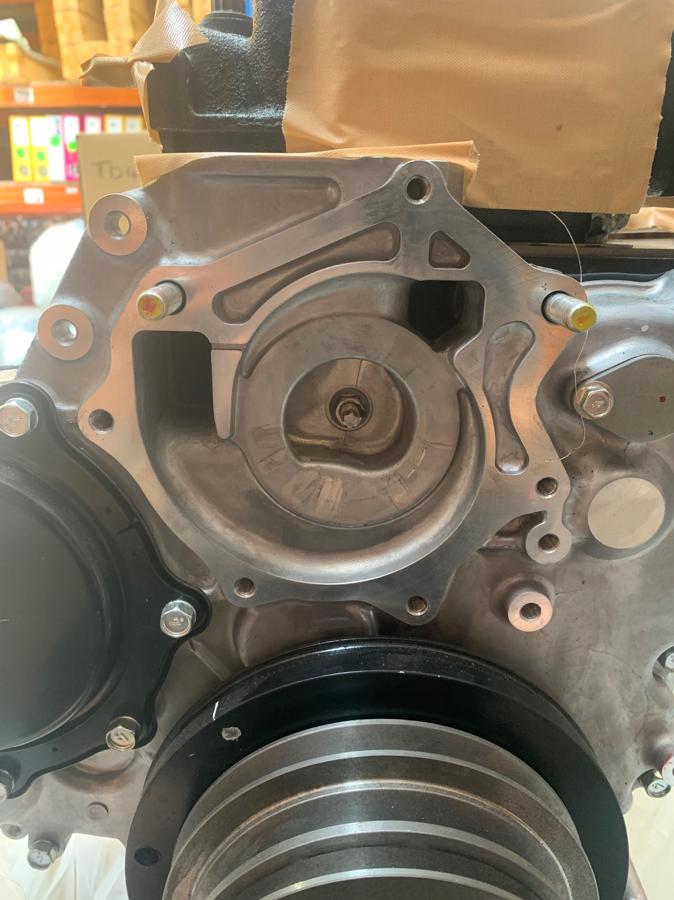

Check your Impellor-to-Timing Case Clearance.
The clearance on these water pumps has been set using a New Genuine Timing Cover, each pump is test fitted after assembly.
With the old water pump pulled off, as pictured above, clean the mating surface back to bare alloy.

We will run you through a couple of steps to check your Air Gap for your specific engine. All of this is to be done dry, with no extra sealant or adhesive to get it correct before final assembly.

Method

Apply a small amount of Blu Tack as pictured below to one of the impellor fins.
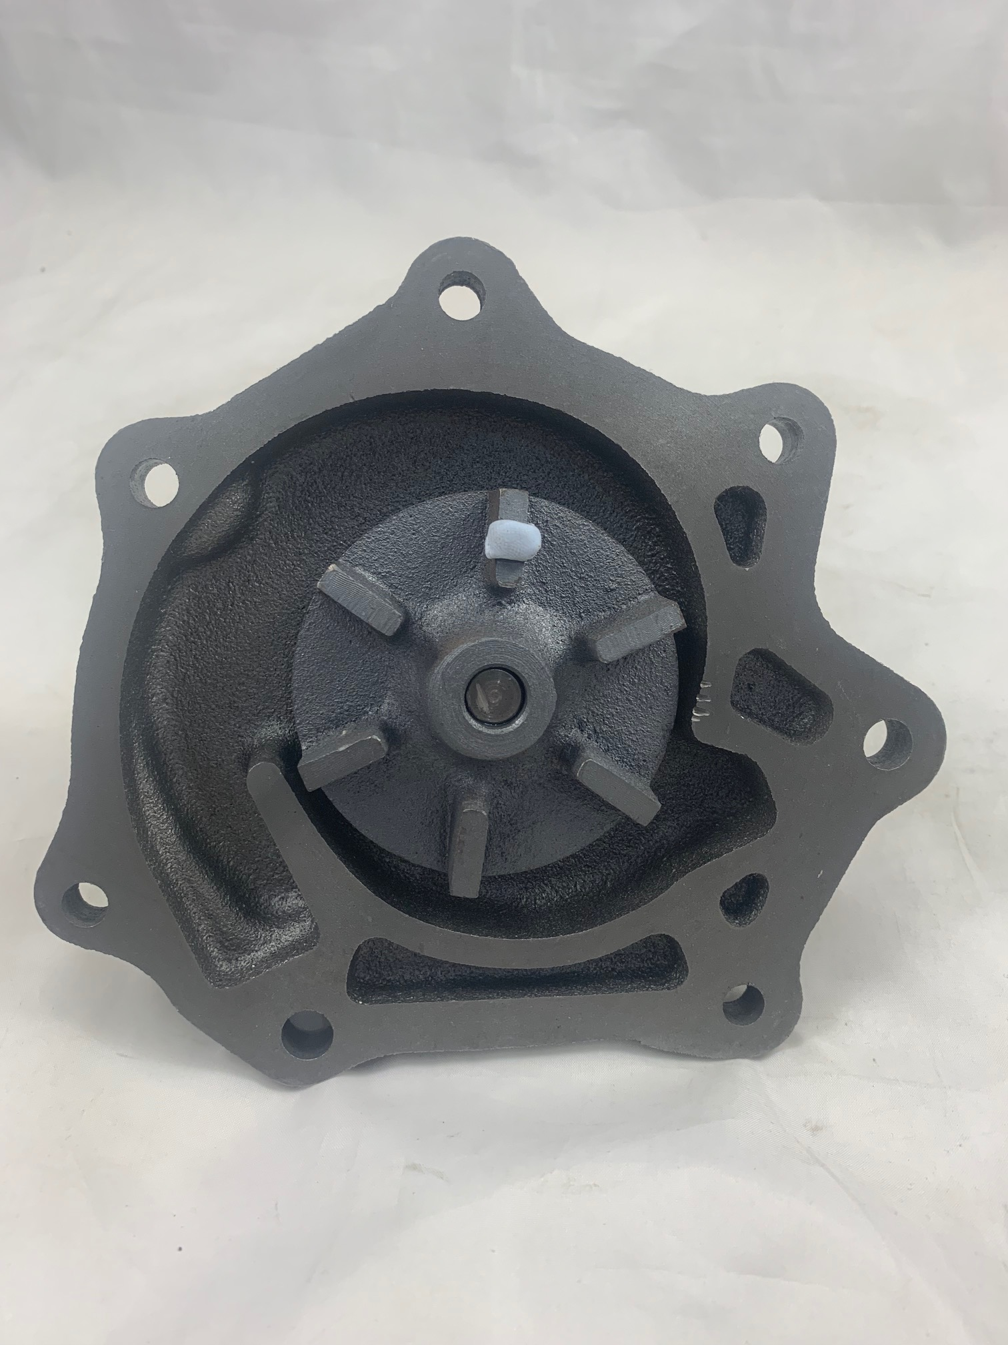

Fit the water pump to the timing case, with the gasket installed, and do up firmly. (we suggest using only the three bolts as circled in the picture below for test fitting).
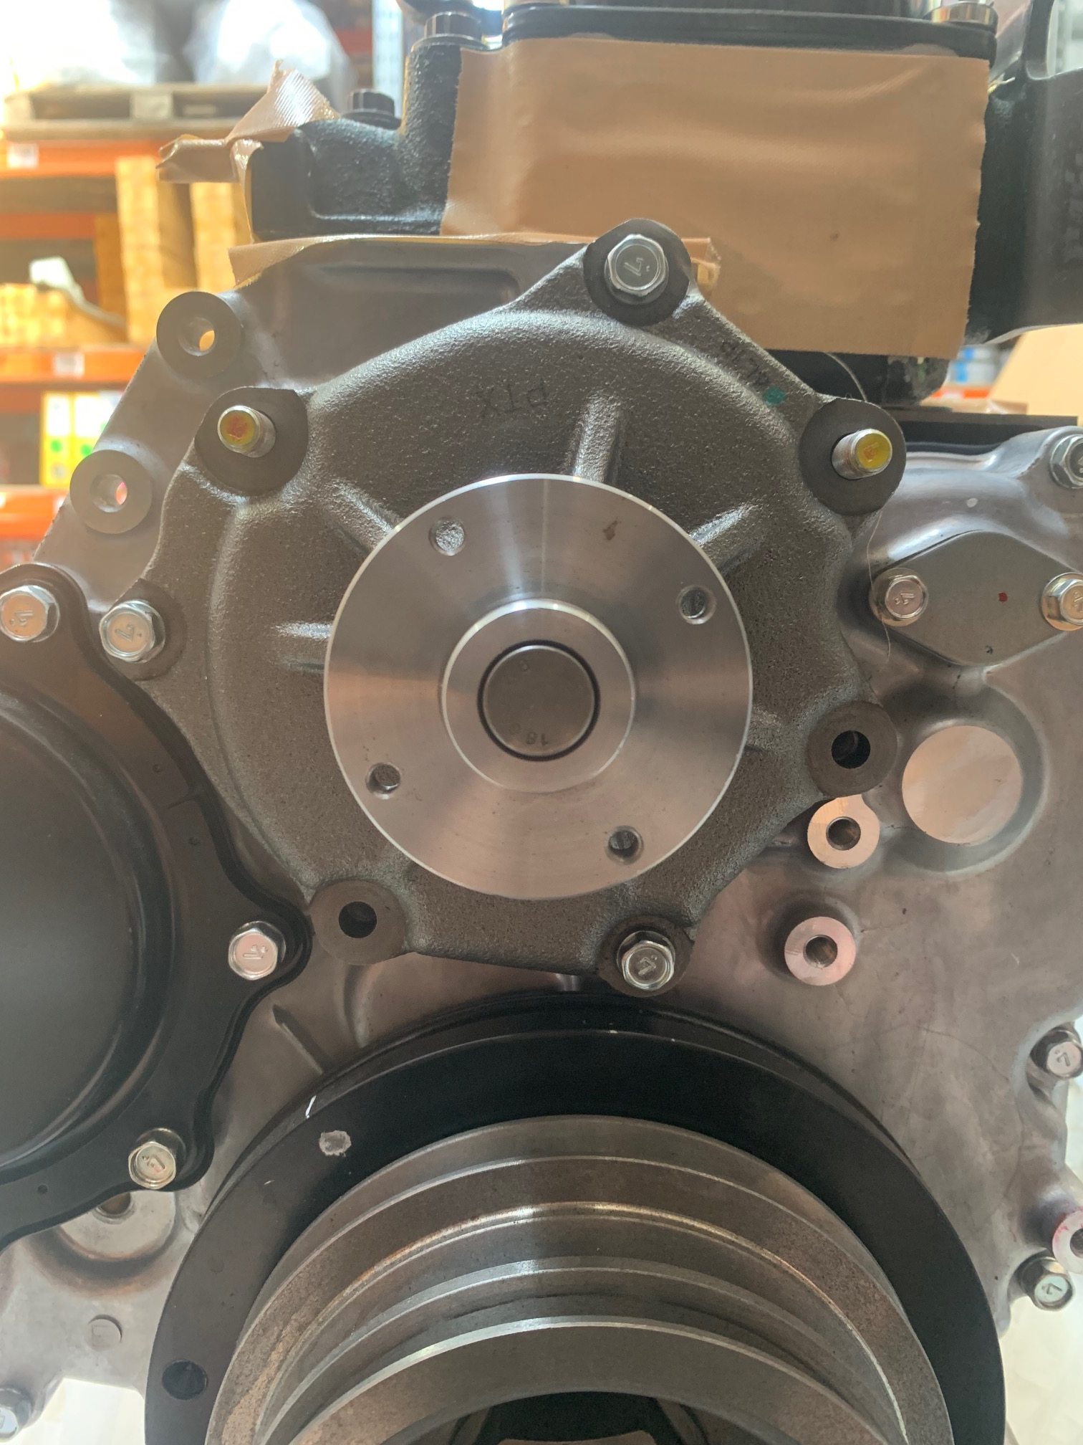

Remove the water pump again and inspect the thickness of the Blu Tack left on the impellor fin. We are aiming for an approximate 1mm clearance.

If you find it is too thick, remove the gasket and try again.

- If you find the Blu Tack splitting apart or squashed out completely after doing this step, then you don’t have enough gap and need to add a 2nd gasket.
Please use the photo below to compare the thickness required of the Blu Tack.
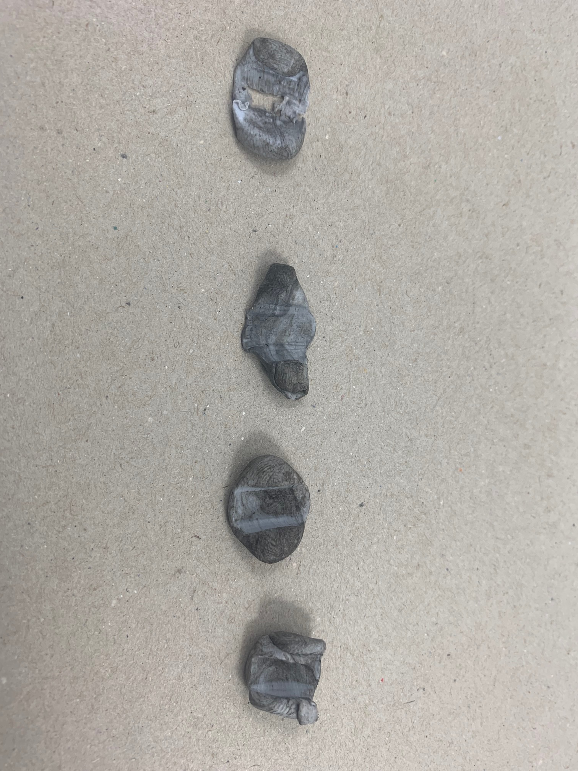

Too thin,
Split apart

Perfect,
Very thin

Too thick
Way too thick

